Local 1085 Brothers and Sisters,
We are updating our Database and would like your cooperation in doing so. Please take a few minutes to update your information and return it to your Steward or Officer. It will help us in contacting you with important information and updates from the Local. We would like to include you in our mass emails in order to notify you and all members of upcoming meetings and events, including pension and contract updates.
The ability to communicate and give you all “up to date” information quickly and accurately is our goal in moving forward. The use of technology is the most cost-effective way to better serve the members.

In solidarity,
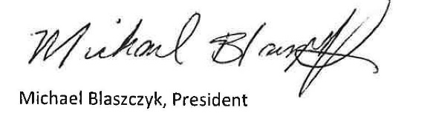

CWA Local 1085

Name (please print):Click or tap here to enter text.

Address: Click or tap here to enter text.

Work #: Click or tap here to enter text. Cell #: Click or tap here to enter text.

Job Title: Click or tap here to enter text.

Department: Click or tap here to enter text.

Work email: Click or tap here to enter text.

Home email: Click or tap here to enter text.

Date: Click or tap here to enter text.

Forms/Member update form.Aug.24.2023

